The International Conference in the format of the High-Level Meeting
«City and Transport: Safety, Efficiency, Sustainability»

4-5 September 2017
Khabarovsk

Draft of the PROGRAMME
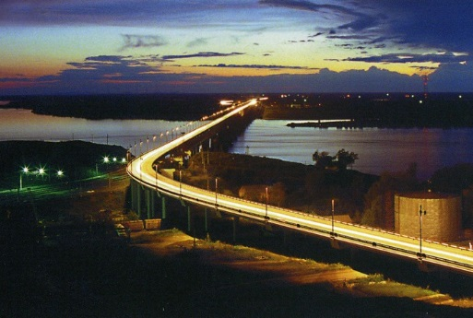
The Conference is held:
- in accordance with the decision of the ESCAP Ministerial Conference on Transport (5-9 December 2016, Moscow, agenda item 9, paragraphs 78 and 97 of the Report of the senior officials segment).

September, 3
Time and place | Event
18.00 | Arrival of participants
20.00 | Evening cocktail reception on behalf of the organizers
September, 4
Time and place | Event
08.30-09.00 | Registration
09.00-09.15 | Official Opening of the Conference.  Welcoming addresses:  - Representative of the Ministry of Transport of the Russian Federation;  - Representative of the Administration of Khabarovsk;  - Representative of the ESCAP Secretariat
09.15-10.45 | Session 1 «General Principles of the Sustainability of Urban Transport Systems. Functioning Role of the State»  During this Session the following issues will be considered:  - the negative effects of transport in urban areas;  - the concept and principles of the sustainable urban transport systems development;  - plans and programs in the field of sustainable urban mobility;  - legislative determination of the goals, objectives and principles of sustainable transport policy;  - economic instruments for internalisation of externalities;  - institutional base for implementation of the policy in the field of ensuring of urban transport systems sustainability;  - implementation of modern methods and tools in the field of traffic management; place and role of traffic management in transport and territorial planning;  - examples of the best practice.
10.30-10.45 | Panel discussion
10.45-11.00 | Coffee break
11.00-12.45 | Session 2 «Integration of Transport and Urban Planning for Transport Demand and Ensuring of Traffic Safety and Quality of Transport Services»  During this Session the following issues will be considered:  - the role of urban planning in solving the problems of rationalization of the transport demand and mobility management;  - the role of improving of transport services quality in shifting the demand to the use of public transport;  - the State's role in integration of town-planning and transport policies and policies in the fields of environment protection and public health;  - principles and instruments for public transport systems planning;  - standards of transport services quality;  - development of electromobility in urban areas (light rail, trams, electric buses, trolleybuses, etc.);  - parking policy;  - examples of the best practice.
12.45-13.00 | Panel discussion
13.00-14.00 | Lunch
14.00-16.15 | Session 3 «Ensuring of Road Safety as an Integral Part of Sustainable Development Transport Systems»  During this Session the following issues will be considered:  - ensuring of urban public transport safety;  - ensuring of traffic safety as an important element of urban and spatial planning;  - improvement of traffic safety in cities in context of " Safe Systems Approach";  - examples of the best practice.
16.15-16.30 | Panel discussion
16.30-16.45 | Coffee break
16.45-17.45 | Session 4 «Role of Non-motorized and Electric Modes of Transport in Modern Cities»  During this Session the following issues will be considered:  - the development of non-motorized modes of transport in urban areas as an alternative of car use;  - cooperation between the State and society in cycling development;  - methods of non-motorized traffic management;  - assessment of the impact of development of non-motorized modes of transport on the efficiency of urban transport systems, human health and the environment;  - the development of public spaces in the cities - the concept of "livable city";  - international, national and municipal projects and programs for the cycling development;  - the concept of multimodal urban streets;  - infrastructure for cycling and walking traffics in the city; bicycle path and bicycle parking; the interaction of public transport and cycling;  - key design elements to create a successful cycling infrastructure;  - examples of the best practice.
17.45-18.00 | Panel discussion
20.00 | Gala dinner
September, 5
Time and place | Event
09.00-10.15 | Session 5 «Modelling of Urban Transport Systems and the Use of ITS and GNSS for Traffic Control»  During this Session the following issues will be considered:  - State policy in the sphere of the ITS development;  - development of traffic monitoring and control systems in urban areas including satellite navigation systems;  - modelling of urban transport systems functioning (methods, software, basic data, usage of the results etc.);  - innovative methods of traffic engineering and control;  - automated systems for the traffic violations control;  - methods of transport surveys and modelling of urban transport systems;  - services for passengers;  - innovative technologies on public transport and their impact on the efficiency and safety of transport systems;  - examples of the best practice.
10.15-10.30 | Panel discussion
10.30-11.30 | Session 6 «Organization of Efficient and Safe Transport Ensuring of a Big International Sports and Cultural Events»  During this Session the following issues will be considered:  - principles and methods of planning transport ensuring of a big sports and cultural event;  - methods of modelling of internal and external transport demand;  - the specific features of the transport ensuring of a big events;  - safety and security arrangements in transport sector during a big events;  - national and foreign experience of transport ensuring of a big events organization;  - examples of the best practice.
11.30-11.45 | Panel discussion
11.45-12.00 | Adoption of the Declaration with the recommendations to the Governments of ESCAP member countries
12.00-12.30 | Lunch
13.00-18.00 | Tour of the City (with visit of some objects of transport infrastructure)

